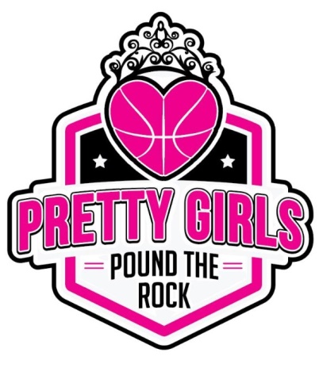

Dear Parent/Guardian:
Please be advised that during Pretty Girls Pound the Rock, LLC events and/or activities your child may be photograph, video, or interviewed. With your consent, the photograph, video, interview may be reproduced and released for use in the media, newspapers, brochures, videos, television, the internet and Pretty Girls PTR website and social media platforms such as Facebook, Snapchat, Twitter, Instagram, etc.

Please indicate your preference below:

(Client’s Name)

YES My child’s photograph/video/interview may be reproduced and released for use in the media

NO My child’s photograph/video/interview may not be reproduced and released for use in the media

(Signature) (Date)
_____

